Thanom Chapakdee

**The Artists’ Front of Thailand**

The Artists’ Front of Thailand (AFT) formed in 1974, immediately following the violent political events of October 1973. The group came together for the purposes of mapping contemporary art and its manifestations and to shed light on the cultural value of the term “Art for Life, Art for People” (“Silapa phua Chiwit, Silapa phua Prachachon”). In the 1970s, many cultural and artists groups rose up to take part in the democratic sphere, and this quickly evolved into a form of Socialist Realism which was integrated with Marxist and Maoist ideology. At that time, the Communist Party of Thailand (CPT) movement was expanding in both urban and rural areas in Thailand. Faced with new freedoms and sharing a hunger for change, the Artists’ Front of Thailand successfully created art to fit this purpose, dealing with subjects such as poverty, nationalism, racism, anti-capitalism, and imperialism, while exhibiting a cynical attitude towards modernity. This was balanced by the figurative nature of their works, a style long ignored during the heyday of abstract art. While the Artists’ Front of Thailand movement lasted only two years, it left a significant legacy of “Art for life” and its aesthetics.

The AFT was born out of a turbulent time in Thailand. Students who participated in the 1973 uprising were fighting and dying for the democratic cause. The AFT promoted the idea of “Art for Life, Art for People” to counter the notion of “Art for Art’s sake”. The group’s manifesto, which was critical of issues of poverty, consumerism, imperialism and the impacts of totalitarianism, was published in 1975.

The AFT was influenced by the Socialist Realist ideas that appeared in Jitr Phumisak’s book *Art for Life, Art for the People*, first published in 1957 and subsequently discovered by students in the Thammasat University library. The book was cheaply reprinted in 1972,along with his essays on art and culture. Many books about socialism were also translated and published in this period, including Mao Zedong’s seminar on art at Yenan, V.I. Lenin’s *On Literature* *and Art*, and Leo Tolstoy’s *What is Art?*

AFT members were predominantly students from the school of Arts and Crafts (Poh Chang), Korat Technical College, and the College of Fine Arts, rather than of Silpakorn University. Members included Kamchorn Soonpongsri (chairman in 1974), Santi Isrowuthakul, (chairman in 1976), Thammasak Booncherd, Chokchai Takpho, Santipaab Nako, Somchai Watcharasombat, Pitak Piyapong, Singnoi Fusawatdisathaporn, Sinsawat Yordbangtoey, Lawan Upa-in, Amnard Yensabai, and Wiroon Tungchareon.

The AFT’s first exhibition was held on Ratchadamnern Avenue in 1974 on the October 1973 anniversary. This was a controversial open-air exhibition of large painted billboards installed along the Avenue. The group’s second exhibition took place in 1976 at Pramane Ground (Sanam Laung), supporting the student-led demonstrations against American Air bases in Thailand. Variations of the exhibition were also held around the country. However, after the Thammasat University massacre and the coup d’etat in October 1976, many AFT members fled into the jungle, joining with the CPT. This led to the collapse of the AFT, but the movement’s legacy continued in left-wing art groups, including the Art Club of Thailand (1979), E-san Group (1983), KungHun Group (1978), Lanna Group (1978), and Dharma Group (1971).

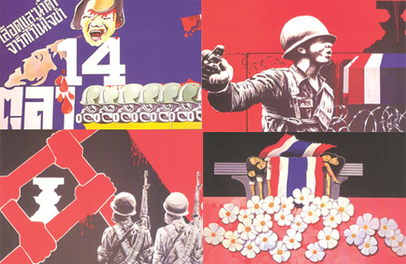

Posters from AFT’s first exhibition in 1974, held on Ratchadamnern Avenue. Pridi Banomyong Institute, Bangkok.

**Reference and further reading**

Leesuwan, Wiboon. (2005) *Art in Thailand: From Siam to Modern art* (Thai). Bangkok, LadPraw Book Center.

Poshyananda, Apinan. (1992) *Modern Art in Thailand: Nineteenth and Twentieth Centuries.* New York: Oxford University Press.

Tungcharoen, Wiroon. (1991) *Modern Art in Thailand* (Thai). Bangkok, O.S. Printing House.

Yensabai, Amnard. (1997) *Western Art: Its Influence on the Thai Art from 1949 to 1979* (Research). Bangkok, Teacher Training Department, Ministry of Education.